Write a program to explain the different ways for displaying output.
PROGRAM:
<!DOCTYPE html>
<html>
<head>
<title>JavaScript Output Methods</title>
<script>
// 1. Using alert()
function showAlert() {
alert("This is an alert box (popup message).");
}
// 2. Using console.log()
function showConsole() {
console.log("This message is logged in the console.");
}
// 3. Using document.write()
function showDocumentWrite() {
document.write("<h2>This text is written using document.write()</h2>");
}
// 4. Using innerHTML
function showInnerHTML() {
document.getElementById("output").innerHTML = "This text is inserted using innerHTML.";
}
</script>
</head>
<body>
<h1>JavaScript Output Demonstration</h1>
<button onclick="showAlert()">Show Alert</button>
<button onclick="showConsole()">Show Console Log</button>
<button onclick="showDocumentWrite()">Show Document Write</button>
<button onclick="showInnerHTML()">Show InnerHTML</button>
<p id="output" style="color:blue; font-weight:bold;"></p>
</body>
</html>
OUTPUT:
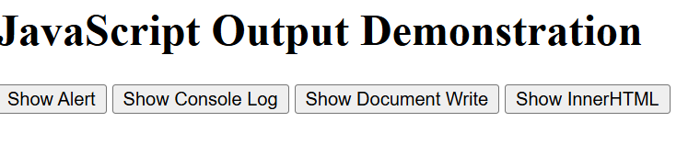
When we click on Show Alert:
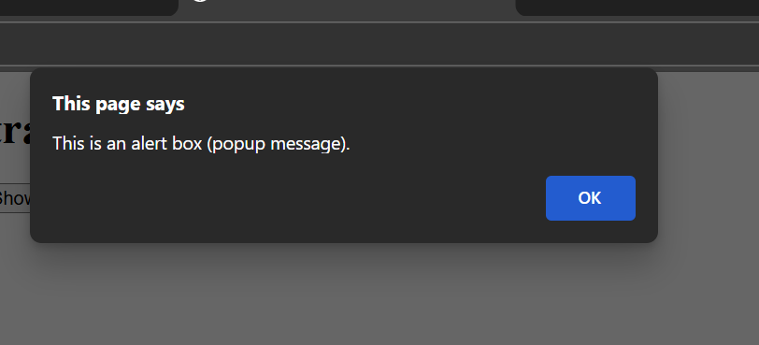
When we click on Show Document Write:
This text is written using document.write()
When we click on Show InnerHTML:
This text is inserted using innerHTML.

